AI-LAB-2.2
2303A52233
Name:Madhavi.ch
Task-1:
Use Gemini in Colab to generate a function that filters out all negative
numbers from a list.
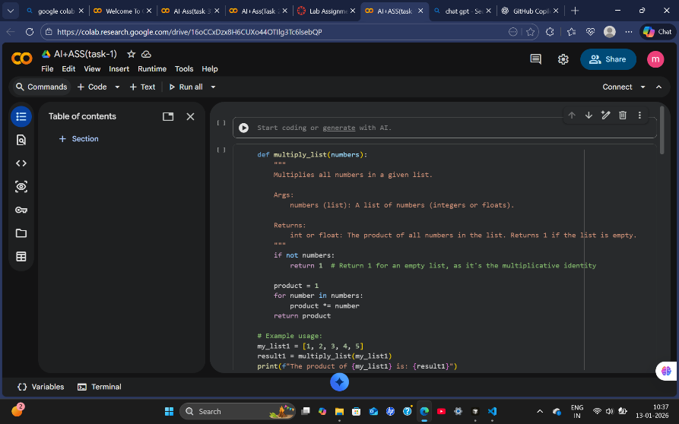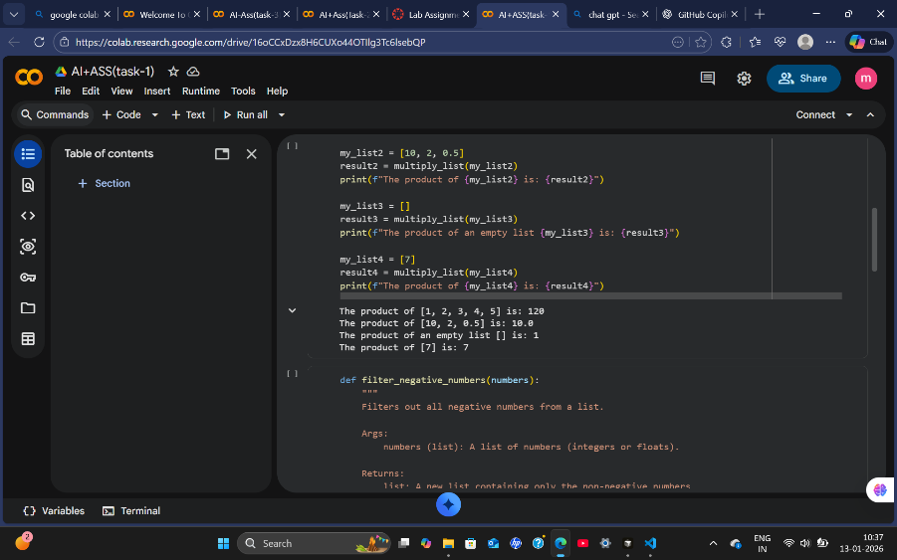
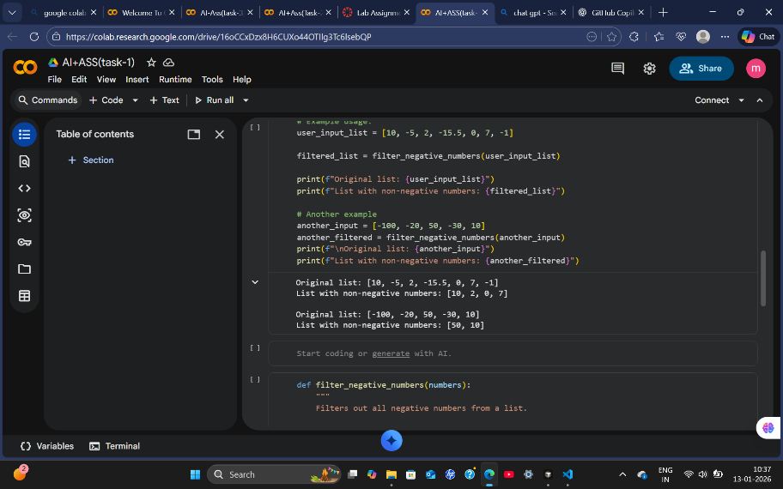
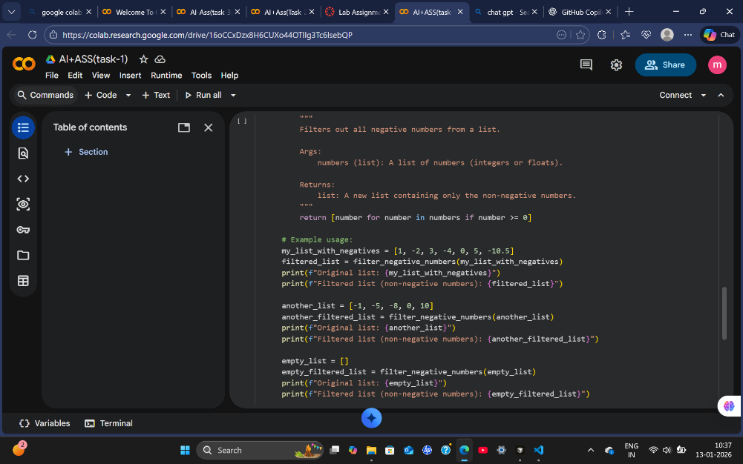
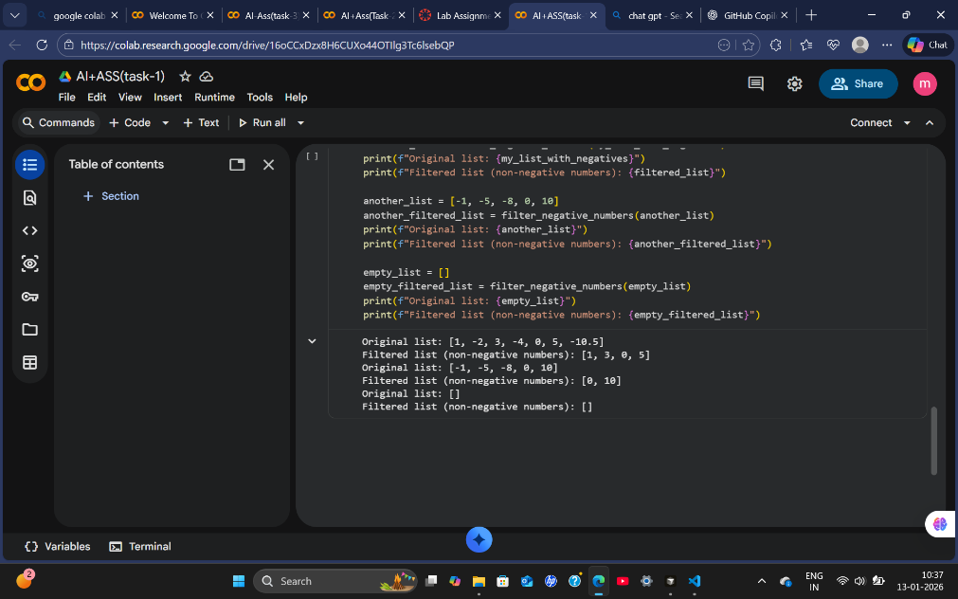
EXPLANATION:
Here I generated code using google colab Gemini -AI on a function that filters out all negative
numbers from a list
Task-2:
Use Gemini to generate a Python function that counts vowels, consonants,
and digits in a string.
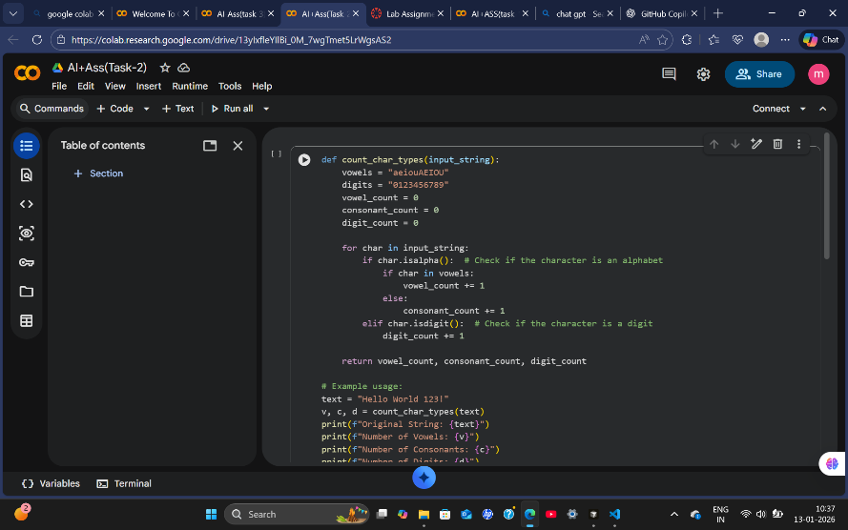
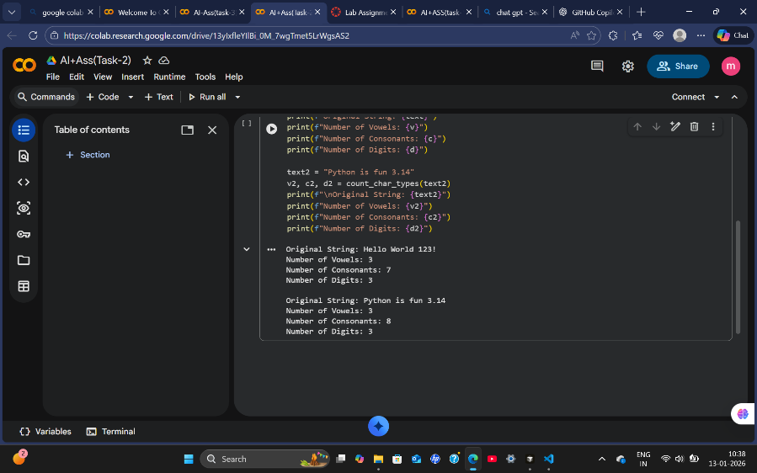
EXPLANATION:
Here I generated code using google colab gemini -aiOn a Python function that counts vowels, consonants,and digits in a string
Task 3:
Generate a palindrome-checking function using Gemini and Copilot, then
compare the results.

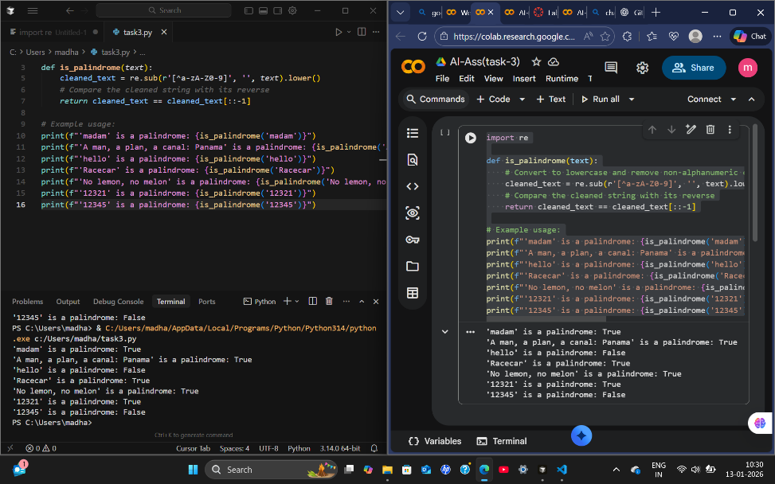
EXPLANATION:
Here I generated code in two platforms they are “Google-colab “ and “Cursor” this two platform given same output but in google colab they we generated code without installing and python generated but in Cursor we have to install .Both are good for output but I think colab is use with search platforms and cursor is use eith Installing method it depend upon specific problem Statement.
Task-4:
Ask Gemini to explain a Python function (prime check OR palindrome
check) line by line.
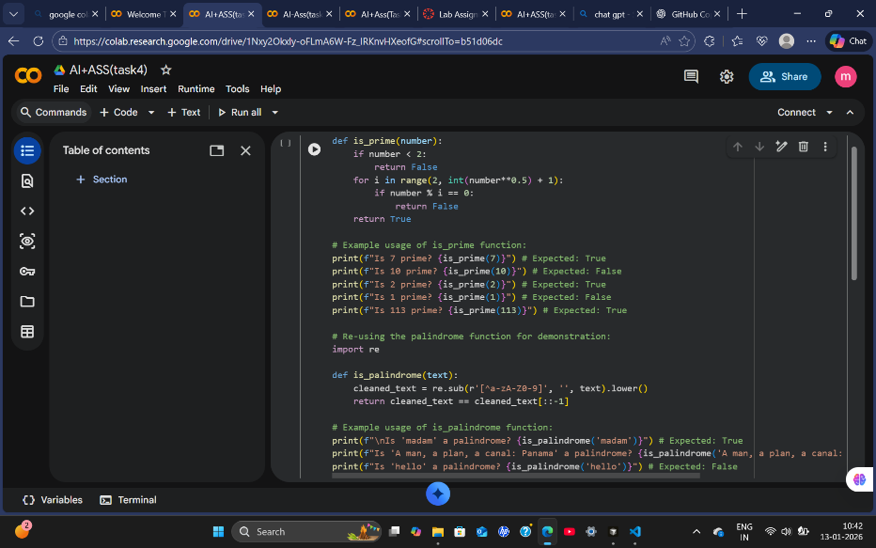
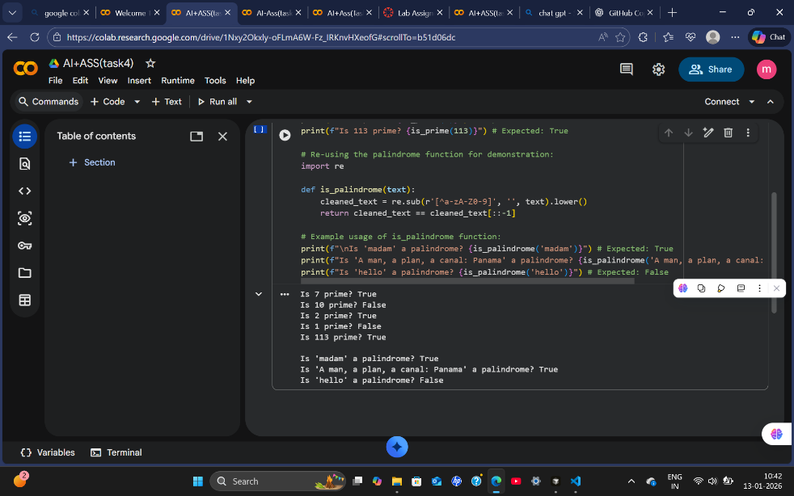
EXPLANATION:
Here we are understanding the other developer code line by line using AI so we can Understand code ad if any change we want to do we can according to the code explanation or we can update the code at specific point by Ai code explanation.

